Electronic & Electrical Engineering Department
Health & Safety Arrangements

The Department is legally obliged to ensure that staff and students performing potentially hazardous tasks are competent to do so safely, and that all reasonable measures are taken to ensure that the risks involved are kept as low as is practicable.
We ensure this by insisting that:
- All activities must be risk assessed in accordance with UCL policy before they are carried out,
- All staff and students must have received and understood all required safety training for activities before being allowed to do them,
- Our facilities, equipment and safety systems meet all the requirements of current safety legislation.
The Department’s Health & Safety Policy statement may be found here.
These pages are a reference of Department safety rules and codes of practice, and ensure that our methods of training staff, safely working in laboratories and offices, and our auditing arrangements are collated, recorded, and made easily available to staff and students.

UCL-wide safety policy documents may be found on the central Health & Safety webpages. These pages contain further safety guidance and a list of available safety training modules. If you cannot find the information you require either on the UCL safety pages or in this document, please contact the department safety officer.
A wide range Health & Wellbeing of resources and guidance is available via the 'Remote not distant' website, Student Support and Wellbeing website and UCL Health and Wellbeing website.
For staff; Care First can be contacted 24/7 for confidential, impartial support. Call for free on 0800 197 4510. For students; support is provided by Student Psychological and Counselling Services (SPCS) during office hours (9am to 5pm)- Care First can also be contacted outside these times.

Key Department Contacts

Head of Department: Prof Sarah Spurgeon #57871
Department Safety Officer (DSO): Dr Kenneth Tong #33019
Deputy DSO: Andrew Moss #33043
Dept. Manager: Paul McKenna #33186
Technical Services Manager: Simon Barnes #33898
Wellbeing Champion: Vicky Coombes #37307
Laser Safety officer (LSO): Prof Cyril Renaud #33982
Chemical Safety Officer: Kevin Lee #33998
Legionella Awareness Officer: Steve Hudziak #33991

Contents

- Covid-19
- What to do if you have symptoms or asked to self-isolate
- Reporting & monitoring

- Mandatory Safety Training
  - Department & UCL safety induction
  - Laboratory workers
  - High hazard activities
  - Refreshing your safety training

- Building access & out-of-hours working
  - Returning to UCL
  - Laboratory Access
  - Security Awareness & Challenge Policy
  - Out of hours/lone working
  - Guest Access
  - Visitors & Agency Staff
  - Permits to work

- Safe working in offices & communal areas
  - Housekeeping & hygiene
  - Meetings, meeting rooms, and communal spaces- covid restrictions
  - Display Screen Equipment (DSE)
  - Electrical safety in offices
  - Manual handling in offices
  - Slips, trips & falls
- Outside the department
- Travelling to UCL
- Remote working/working from home
- Visiting other institutions, conferences, travel etc.

- Reporting safety concerns & building faults
- Reporting routes
  - Building faults and defects
  - Regulatory & policy non-compliance

- Risk assessment
  - When is a new risk assessment required?
  - Creating a new risk assessment
  - The RiskNet system

- Accidents, injuries, and emergencies
  - First aid & Medical Emergencies
  - Accident & incident reporting
  - Fire Safety
    - Fire evacuations
    - Personal Emergency Evacuation Plans (PEEP)
    - Fire exits & fire doors
    - Firefighting and fire controls
    - Fire drills
    - Instructions for labs & workshops
    - Fire safety symbols & signage
  - Contingency plans
    - Low oxygen and cryogen emergencies
    - Laser eye injuries
    - Electrical shock

COVID-19
As they have in so many areas of life, covid safety controls affect nearly all aspects of department safety policy. It is hoped that most (if not all) of these controls will be steadily reduced and removed from the 17th of May 2021 onwards. UCL intends to return to normal by the start of the 2021/22 academic year, with most staff able to begin a return to site from the 21st of June 2021.
Some key information about what to do if you have symptoms or a positive test result are provided below. More information can be found on the UCL coronavirus information webpage.

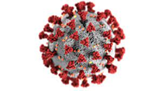
Covid-19 controls specific to each section of this document are identified by this graphic. This information may change in line with UK Government and UCL guidance.

What to do if you have symptoms or asked to self-isolate
If you are feeling ill, you must not come to work. If you become ill onsite you must inform your line manager/supervisor immediately and return home.

If you develop symptoms related to Covid-19, please follow the guidelines set by the government, and take the following steps:
- Contact the national Test and Trace Service.
- Use the ‘Connect to Protect’ tool to confidentially inform UCL.
- Inform your line manager or supervisor. This information will be taken in confidence.
- Self-isolate in line with NHS guidance
Please also notify your manager/supervisor and use the ‘Connect to Protect’ tool to report:
- if you have been required by NHS test and trace to self-isolate due to contact with potentially infected individuals.
- if after testing you subsequently receive a positive result.
UCL is also providing a local Covid-19 testing service for students and staff. Please see the UCL coronavirus testing website for more information.
For more information about coronavirus and what to do if you feel unwell, please see UCL advice here.

Reporting & monitoring
Staff and students should report social distancing failures to their line manager, supervisor, or the local lab manager. Alternatively, they may report issues in confidence to the department safety officer, deputy safety officers, heads of group or directly to the head of department, or anonymously via RiskNET.

Incidents will be dealt with on a two strikes system:
- On a first offense the individual(s) involved will be given a verbal warning by the department safety officer.
- As second offense will result in an access ban to all work on site for a period no less than two weeks, followed by a requirement to recomplete local safety briefings.

Departmental services during Covid
Deliveries of post and packages are still being made regularly to the department from the central UCL Post Room. The department office is staffed three days a week to receive and distribute the post and other deliveries.
Communication with Department IT services, workshop and administration will remain by email, phone, or MS Teams in the first instance.
An in-person service will be available only by prior appointment, and each service will have conditions that must be observed- there will be no ‘walk-in’ support provided by department support services.
These restrictions will be reviewed before 21st of June 2021.

Mandatory Safety Training
All new staff and postgraduate students must complete the Department’s local fire & general safety induction. These inductions are held monthly by the Department Safety Officer (DSO). New starters should attend a session as soon as possible after arrival- you will be contacted with the next available date. These sessions are held virtually via Zoom or MS Teams.
As part of their mandatory training, new staff and postgraduate students must also complete the online UCL Safety Induction and UCL Fire Safety training courses. These must be completed within one month of the start of employment/enrolment.
- UCL Safety Induction
- UCL Fire Safety training

While covid-19 controls are still in place, new starters must also complete the ‘return to UCL’ covid-19 safety module as part of the mandatory training.

Note that visiting and agency staff and visiting students who join the department for extended periods (e.g. a week or more) are treated in the same way as any of our permanent staff or students for training purposes.
People visiting for less than a week are considered guests of the department. Unlike official visitors they do not have to undertake training, but they should be escorted at all times by a staff member. They must not be allowed or expected to perform any hazardous tasks that require safety training.
Staff members may require other safety training, depending on your role and responsibilities, such as:
- Manual Handling and Lifting training
- Emergency First Aid at Work training
Your line manager will discuss with you any further safety training you may require.

Prospective laboratory workers
New lab workers must:
- Have completed all mandatory safety training as described above
- Completed the UCL online training module Principles of Risk Assessment
- Received a laboratory safety induction from a lab mentor (a competent person permitted to train new laboratory users), which covers the key risks and controls in the laboratory and any local covid safety measures in place.
Access will be permitted once these steps are completed.

Specialised and high-hazard laboratory activities
These activities may require further training before they may be performed by staff and students. Access permission to some laboratories, and permission to operate certain machinery and equipment, requires successful completion of this training.
These activities include:
- Use of class 3B and class 4 laser systems
- Use of X-ray generating equipment
- Working safely in a cleanroom environment
- Working with cryogenic liquids and compressed gases
- Working with hazardous chemicals, and COSHH (control of substances hazardous to health) risk assessment
- Activities in the Department mechanical workshop
Note that this list is not exhaustive, and you may be asked to undertake further instruction before being allowed use of certain equipment.
Do not assume because you have been given access to an area that you are allowed to use all of the equipment within it. If in doubt, check with your supervisor, line manager or the laboratory manager before proceeding.

Refreshing your safety training
Fire safety training is valid for two years, after which it must be refreshed. To do so:
- Re-complete the UCL fire safety training module
- Re-read the department Fire Safety information, noting any changes to fire escape routes
- Undertake a self-led ‘fire walk’ from their usual workspaces to the building fire assembly area, so you are familiar with the route.
- Record the training by completing the fire induction record form and send this to the technical services manager to be archived.
All other training is valid for three years from the initial training date. Staff and students should undertake refresher training once three years have passed. For staff, H&S training refresher courses should be identified as part of the annual appraisal process.

Building Access & Out-of-Hours Working

UCL buildings require a staff ID/pass card to enter. You will be directed to the UCL security office in the Andrew Huxley Building to collect this card on your first day. Please see the Security webpages here for more information on your pass card.

Most Department floors in the Engineering buildings are open during normal working hours (7am to 7pm, Monday to Friday, excluding closure days and national/bank holidays). Outside of these times, corridor entrances require a pass card to enter. The exception are floors hosting our high-hazard lab facilities, which have more restrictive access.

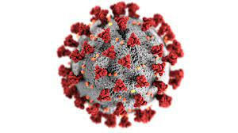
Returning to UCL

Until further notice, to assist in controlling the spread of covid-19, the department has put corridor card entry systems into 24/7 operation.

Staff and students must request access to the department in advance.

All returning staff and students must:
- Complete both the UCL online and local fire safety refresher (see more information here)
- Complete the ‘return to UCL’ covid-19 safety training
- Received an up-to-date copy of the department safety arrangements (this document)

Returners who will be doing laboratory work must also provide a valid RiskNet risk assessment reference, and evidence they have read and understood any laboratory covid rules for their area.

From 17th May 2021, access for the following work is permitted:
- Practical research work in lab spaces
- Teaching activity
- Support tasks for the above, and maintenance/inspection tasks

We will, with the agreement of the line manager or supervisor, also allow conditional and limited office access for colleagues and students who are struggling with an unsuitable home working environment.

More general office access will be permitted from 21st June 2021.

Line managers and supervisors are also requested to ensure that returning staff and students ensure their display screen equipment assessment for their on-site workspace is up to date.

Laboratory Access
Some laboratories in the Department also use a pass card for access, but most use a combination of key and code pad system for entry. You will be added to the pass card entry lists for a laboratory, or given the code and/or key, following completion of the required safety training.
Most offices in the Department use a key entry system. You will be given your office key on your first day of employment/enrolment.
Office & lab keys are managed by the IT team. There is a £20 deposit for keys, so try not to lose them!

Security Awareness & Challenge Policy
Due to its very public central London location and a largely open site, UCL buildings have occasionally suffered unauthorised entry and thefts.
We therefore ask all our staff and students to try to be as security aware as possible, namely;
- Watch out for people trying to tailgate you when entering via exterior doors and through card barriers on entry to buildings,
- Don’t leave office and lab doors intentionally open or accidentally ajar,
- Don’t allow people you don’t recognise entry to offices and labs if they don’t have a key or pass card,
- Report any people acting suspiciously to Security.
Due to the possibility of physical threat, we do not recommend you directly challenge people acting suspiciously. Instead, contact Security personnel, either in person or via phone on 020 7679 2222, with a location and description of the people concerned. For more information see Staying Safe at UCL on the Security Services webpages.

Out of hours & lone working
If members of the department will be working alone in offices or laboratories before 7am or after 7pm, or at weekends, it is essential for them to inform the front Security Lodge (ext. 32108) of their presence and their departure.
Department policy is to generally restrict laboratory work to normal working hours (as defined above).
Individuals may still come into the Department outside these hours to work in offices. However, experimental work should not be performed unless:
- the academic supervisor authorises it on a one-off (i.e., not regular) basis;
- the laboratory manager agrees that the work is safe to perform in these circumstances;
- a second worker is present to assist at all times if the task has been risk assessed as unsuitable for lone working.
This should be regarded as exceptional rather than normal working practice and a record should be kept of the authorisation.
Lone working is not permitted at any time if an activity has been risk assessed as too hazardous to perform alone. Note that having others present periodically in the area is not sufficient to count as group working; the supporting workers must be able to give their full attention to assisting the primary worker.

Lone working should be avoided wherever practicable- but it is recognised that with lower occupancy rates during the pandemic, it will be inevitable that staff and students will often end up working alone.
Safety services recommend:
1) Staff & students use a ‘buddy’ system when working alone. For lower risk activity, your buddy can be remote and contacted by phone (WhatsApp, MS Teams). For higher risk work, your buddy must be close, but can be in an adjacent room in order to maintain social distancing.
2) Teams should co-ordinate activities and attendance in advance of lone work taking place.
- Contact your manager (or another buddy) when you arrive in your department.
- Make follow up contact every 30 - 60 minutes to say you are OK.
- Contact your manager (or other buddy) when you leave work.
- Contact your manager (or other buddy) when you arrive home.

Guest access
All guests and short-term visitors must report to the Departmental Office (Room 705) on arrival. All guests are the responsibility of the member of staff inviting them, and they are expected to follow UCL’s Code of Conduct for Visitors. Guests are to be made aware of emergency procedures and if requested given a copy of the Department Safety Policy Statement.
The following restrictions on access apply:
- They should not be loaned keys, access cards or told access code details.
- They should be accompanied at all times.
Note that access to laboratories in this case is primarily permitted for observation; guests and short-term visitors are not expected or permitted to perform hazardous tasks that require mandatory training.

Visitors & Agency Staff
Visitors and agency staff spending extended periods in the department must follow the same rules and requirements as any other staff member or student. Sufficient notice should be provided to departmental administrative and support staff so that ID cards & keys may be arranged, and training needs identified, prior to the visitor’s arrival.

Permits to Work
Repair and building work by UCL Estates personnel and contractors in laboratory areas requires ‘Permits to Work’ to be arranged with the laboratory manager and/or Technical Services Manager (specifically, a ‘type D’ permit). If you are working in a laboratory, you should be notified in advance if works will take place; if you find contactors in a laboratory unexpectedly, please notify the laboratory manager or the Technical Services Manager. Please also direct any Estates or contractor access requests to the laboratory manager or the Technical Services Manager.
Note if access to high-hazard areas is required by contractors, this should also first be agreed by the Departmental Safety Officer.

Safe working in offices & communal spaces
We expect all staff and students to share responsibility for the general cleanliness of their offices and for keeping the shared areas of the Department free of spillages, clutter, food and accumulated rubbish.
Building faults and damage should be reported to defects@ee.ac.uk.
We expect staff and students to avoid creating obvious health and safety hazards such as trailing wires and other trip hazards, unstable filing cabinets, blocking fire escape routes etc.

Housekeeping & Hygiene
- Don’t bring laboratory activities into offices, especially anything involving open mains voltage equipment or chemicals
- Don’t block doors, especially fire exits
- Don’t allow your office area to become cluttered with trip hazards or unstable storage
- Don’t leave waste or packaging in the corridor assuming someone else will deal with it for you
- Don’t leave food waste or dirty plates/cutlery in offices
- Keep communal areas and shared appliances clean and tidy
- Use or dispose of food in fridges before it goes out of date.

In general, if you make a mess, clean it up! If you are expecting to create a lot of waste (e.g., a large order is arriving with lots of packaging) request for a collection by the porters via defects@ee.ucl.ac.uk.
The wearing of masks or face coverings is required when moving around buildings and the wider UCL site unless you have a medical need to not do so.
Masks are not required within shared offices, labs or workshops provided social distancing can be maintained and the room is well ventilated.

Hands should be washed or sanitised after entering a building, moving between buildings and between rooms in buildings, before

and after eating and drinking, after using communal facilities, after touching high contact surfaces such as door handles, and when arriving home. For handwashing advice see the NHS guides here. Toilets should be flushed with the lids closed to prevent splashes and aerosols.

Hand sanitising facilities are available at the front entrance to the Roberts building and MPEB. Hygiene stations with hand sanitiser, disinfectant wipes and pare face masks have been set up in labs and shared offices. If you find stocks have run low, please email defects@ee.ucl.ac.uk to report.

Many of UCL’s buildings are very old, and there are inevitably pest problems. You will see traps in our corridors and communal areas, and in some offices; please do not touch these as they contain poison. You can help avoid pest problems by ensuring you do not leave food or food waste in offices.

If you find issues with the building in your work area - leaks, faulty heating/cooling, damage to floors or walls etc. Please raise a report by emailing defects@ee.ucl.ac.uk. If the problem is urgent contact the Technical Services Manager directly.

Please report faulty furniture either via defects@ee.ucl.ac.uk or directly to the Departmental office in room 705. It is very important that any furniture with damaged fabric is reported as soon as possible- once the foam interior is exposed, the furniture is no longer fire safe and should be replaced immediately.

For more information on reporting faults and safety issues, please see the Reporting Safety Concerns pages.

Meetings, meeting rooms & communal spaces – covid restrictions

Movement through department corridor spaces and stairways will be on either a ‘keep left’ or one-way system. Please keep to 2m distancing. Do not wait in corridor areas. Please follow all instructions on covid-19 signage.
Lift access will be substantially reduced as only two people will be able to ride each lift at any given time. All staff who do not have mobility issues should use the stairs in the first instance.
From the 17th of May 2021, in person face to face meetings in offices may resume, subject to the following constraints:
- Meetings may only take place between at most two people in personal offices.
- Informal meetings in shared offices must still comply with the ‘rule of six’ until June 21st, 2021.
- Occupancy limits for shared offices must still be observed
- Two-metre social distancing should be observed
- Windows should be kept open to allow fresh air to circulate
Department meeting rooms will be available to book from the 17th of May 2021 for in person face-to-face meetings. Meetings must still comply with the following restrictions:
- Two-metre social distancing should be observed
- The ‘rule of 6’ will still apply until the 21st of June 2021.
- Windows should be kept open to allow fresh air to circulate
- Attendees should sanitize their hands on entry/leaving
- Attendees should wipe down the space they have occupied (using the disinfectant wipes provided) at the end of the meeting.
Please contact Joe Hird to arrange bookings.
Please note, masks are not required in meetings when attendees are seated and can remain socially distanced. While moving around the room, entering/leaving, or where attendees must move within two metres of each other, then masks or face coverings must then be worn.
The Cullen room kitchen remains open and available for use. The kitchen will be for the preparation of food and drinks only- not for socialising or consuming food/drinks.
  - Staff and students using the facility must clean any shared appliances, surfaces etc. with the cleaning materials provided, both before and after use.
  - Only one person may access the kitchen counter & sink area at any one time. A two-metre distance box will be marked out on the floor.
Staff and students must not share food and drinks or prepare food and drinks for each other. Where possible, we recommend that staff and students take their food drink to consume outside but recognise that this may not be possible and that it may have to be consumed in office spaces.

Display Screen Equipment
All staff & students who work with Display Screen Equipment (DSE) – e.g., PC monitors, all-in-one PC screens, and also portable systems such as laptops and tablets- are required to complete a DSE assessment for their use in the workplace.
Should you also work the majority, or a significant minority, of your time from home, you should also complete a DSE assessment for your home workspace- please see the ‘working from home’ section for more guidance.
This assessment is completed using the RiskNet system; new staff and postgraduate students will receive an email invite from Safety Services to complete an online DSE self-assessment via RiskNet and a presentation about the DSE assessment process.
If a user’s DSE assessment suggest extra support is required, the Department’s DSE lead will be informed and they will contact the user for a face-to-face assessment of their DSE needs.
DSE related Health and Safety issues may also be brought directly to the attention of either the DSE lead or the Departmental Safety Officer.
More information may be found on the Safety Services DSE pages.

Electrical safety in offices
We ask that staff and students act responsibly with electrical equipment in offices and communal areas:
- Don’t overload sockets or ‘daisy chain’ power extension blocks,
- Don’t run trailing electrical cables where people may trip over them,
- Check for signs of damage (especially frayed/exposed cables) before using equipment.
Although you are permitted to bring your own electrical equipment in to the department (phone chargers for example), we ask you to be wary of cheap electrical equipment bought online; often it does not meet UK safety standards.

All UCL mains powered electrical equipment must be checked periodically to ensure it is electrically safe. This is done either by performing a Portable Appliance Test (PAT) or a visual inspection. Unless it is a brand-new item (that is still under manufacturer warranty) any mains powered equipment that you are provided should have an in-date PAT or have had a visual inspection- usually the record will be a sticker or mark on the item. If you suspect that your equipment may be out of test, please report this to defects@ee.ucl.ac.uk.

Please note, all department office IT equipment is generally replaced after the warranty has expired, so will not have a PAT record.
Please be aware that electrical equipment has to be disposed of correctly and cannot be put into normal waste. Please bring this type of waste to the IT team who will dispose of it with the IT waste.

Manual handling in offices
You should only move equipment, items, stationary etc. if you are confident that:
- The load is not excessive for your ability to lift and/or carry,
- It is not so bulky as to be unwieldy, or is slippery/difficult to grip
- The location does not require you to move or lift in an awkward way,
- The items are not in an inaccessible place, with a risk of falling or tripping.
If possible, break loads into manageable sizes, ask a colleague to assist, make a safer working space by clearing other items in the way, etc. Please see the UCL guidelines on manual handling for further advice.
The movement of items that remain very heavy for more than one person to lift, are very bulky or unwieldy, or stored inaccessibly, should only be led by staff who have completed UCL’s Manual Handling and Lifting course. Movement of such items should be done in accordance with the Department’s manual handling risk assessment for office equipment. Wherever possible, lifting aids (sack barrows, trolleys, pallet trucks, etc.) should be used.
Individual large heavy pieces of office equipment and furniture should be handled by arrangement with UCL Porters. Please ask the Technical Services Manager to arrange.

Slips, trips & falls

By the far most common injuries in workplaces are caused by slips, trips, and falls. Trip, slip & fall hazards can be minimized by keeping your work area clean and tidy, reporting damage (loose tiles, torn carpets etc.) and performing manual handling tasks safely, as discussed above. The risk may also be reduced by staying safety aware and acting conscientiously on shared spaces:
- Do not run in corridors
- Don’t push past people if they (or you!) are carrying things, especially hot drinks
- Don’t block routes when stopping for conversation with others
- Pay attention to where you are walking (don’t become focussed only on your phone!)
Liquid spills should be cleaned up- large spills or floods may be reported to Estates Cleaning Services via the department office. Please mark any large spills/floods or damp, slippery floor areas with warning signs to alert others to the hazard- these may be obtained from the department technical team.

Outside the department

Travelling to UCL

Until June 21st, UK government advice remains to work from home where possible. On site working should take place during daytime hours (7am to
7pm) if at all possible (see lone working).

Please check the UCL coronavirus website and the regular Covid-19 updates (via email) to ensure information is up to date before travel each day. If using public transport, check the operator’s travel updates before leaving home.

Please follow this general travel advice:
• Plan ahead and use a direct route
• Travel at 'off peak' times, which means avoid travel between 06:30 to 09:30 and 16:00 to 19:00, Monday to Friday
• Take hand sanitiser, and wear a face covering or mask- these are mandatory on all UK public transport.
• Wash or sanitise your hands frequently, particularly before beginning your journey and when you arrive
• Try to maintain 2 metre social distancing, for example when approaching or passing other people, waiting at crossings and traffic lights, waiting on platforms etc.

Working from home/remote working
There is no requirement to do a DSE assessment for brief periods of remote working (if you only do an occasional home-working day, for example no more than once per week on average). However, you should still carry out self-checks of your home workspace:
- Try to think about finding a space within your home environment that enables you to work undisturbed, has sufficient lighting (preferably natural daylight) and is maintained at a comfortable temperature.
- If you do not have access to an office desk and office chair at home, make good use of any table and chair, as opposed to sitting on the sofa or in bed.
- Ensure you take regular breaks.
- Try to stand up and move away from the computer during these breaks, giving your body a rest from sitting in the same position for long periods.
- Using a separate monitor, keyboard and mouse is also recommended instead of using a laptop and trackpad, if available.
Colleagues and students who work either the majority, or a significant minority of their time at home should complete a Display Screen Equipment (DSE) assessment for their remote workspace, in addition to their DSE assessment for their on-site workspace.

Where recommendations arise from remote working DSE assessments, the department & UCL will bear the cost of measures where they are considered proportionate.

The most common issues remote workers identify can often be resolved with items costing £50 or less:

- Keyboard & Mouse: to attach to a laptop for greater comfort and usability than a touchpad/integrated laptop keyboard

- Footrest: if feet do not touch the floor when seated or user requires foot support

- Laptop stand: allows laptop screen to sit at correct eyeline without requiring external monitor

- Extra back support- mesh back/lumber support for chairs for users with back issues

If you feel that an under £50 item will assist with issues identified in your assessment, these can be purchased and reclaimed as an expense. Please note that research staff will need to discuss any purchases they wish to make for remote working with their supervisors prior to making any purchases.

The department appreciates that not everyone has a suitable work area or furniture that can be adapted easily this easily. If necessary, the Dept. will also meet the cost of larger items over the £50 threshold, for example:

- Basic office desks
- Office chairs
- Adjustable platforms to adapt desks/tables to standing-height desks

Where equipment or furniture costing over £50 is necessary, please contact the Dept. Finance Manager in the first instance.

The Department recognises these items may still be insufficient, particularly if you have specific health issues or accessibility needs. Please contact the Department DSE advisor in such cases to discuss your support needs.

Visiting other institutions, conferences, travel etc.
Off-site working is any teaching, research or work activity carried out by UCL staff, students or visiting research workers on behalf of UCL in places or premises which are not rented or owned by UCL.
A generic risk assessment covering key risks associated with TRAVELLING TO AND FROM MEETINGS, EVENTS AND CONFERENCES (staff and students) at other institutions or locations in the UK or abroad is available through riskNET - search for RA042911/2 – Title: UCL Generic Risk Assessment for travelling to and from meetings, events, and conferences (staff and students).
A specific risk assessment will be needed if you decide to do collaborative research or fieldwork in addition to attending a conference or meeting, if you will be visiting another institution specifically to do research there, or if you are a member of a vulnerable group (for example people more at risk due to their ethnicity, age, disability, or status as new or expectant mothers).
For further guidance on the process of risk assessing visits to other sites, conferences, undertaking fieldwork etc. please see the off-site working pages on the Safety Services website. For more guidance on risk assessment & RiskNet please see the risk assessment section.

Reporting Safety Concerns & Building Faults

Reporting routes
Should you have a safety concern about you work or workplace, the first instance you should raise the issue with the laboratory manager for the area and/or your supervisor or line manager.
If they are unable to resolve the issue, or if you do not feel comfortable raising it directly with them, you may also speak in confidence with the department safety officer and/or the responsible officer for the work type (e/.g. for a laser-related safety issue, contact the dept laser safety officer). In extremis, you may raise your concerns directly with the Head of Department.
For less immediate problems, or for suggestions and feedback on safety, contact your peer safety representatives- UGs, Postdocs & Researchers each have a have safety representative on the department safety committee.
Safety concerns may also be reported using the RiskNet Accident & Incident reporting system (please see the Accident & Incident Reporting section for more information). They can also be raised directly with UCL Safety Services – contact Dev Agarwal, the central Safety Advisor assigned to EEE.

Building faults and Defects

If you find issues with the building in your work area - leaks, faulty heating/cooling, damage to floors or walls etc. please raise a report by emailing defects@ee.ucl.ac.uk. If the problem is urgent, please also contact the Technical Services Manager directly.

Should there be safety implications for the fault- for example, if you believe it may have caused a near miss, or it may lead a threat to health, please also raise an incident report in RiskNet and notify all relevant department persons, as explained in the previous section.

Please report faulty furniture either via defects@ee.ucl.ac.uk or directly to the Departmental office in room 705. It is very important that any furniture with damaged fabric is reported as soon as possible- once the foam interior is exposed, the furniture is no longer fire safe and should be replaced immediately.

Regulatory & policy non-compliance
The rules set out in our policies and in national regulation are there for good reason- to ensure we all work safely, and no one is exposed to unnecessary risk.
Please always:
- Follow all UCL, department, and laboratory safety rules
- Report accidents & safety incidents you are involved in honestly and promptly
- If you spot colleagues or fellow students not following safety rules report this in confidence using one of the routes listed above.
Failure to follow safety rules will be treated extremely seriously and will likely result in disciplinary action.

Risk Assessment

The purpose of a risk assessment is to identify the hazards involved in a procedure, to set out how those hazards are to be controlled, and to communicate that information to those who need to know.

UCL policy requires that all hazardous activity must have a suitable and up-to-date risk assessment, and these assessments must be recorded in the RiskNet system. Any person who is going to carry out any new activity involving a hazard must conduct a suitable and sufficient assessment of the risk, and establish any required control measures, prior to starting the work.

To be valid, risk assessments must be authorised within RiskNet by a competent person. For research students, this person will usually be their supervisor, and likewise for researchers this will usually be their line manager. However, where someone is working in a lab outside of their supervisor or line manager’s direct control, it may instead be the laboratory or facility manager or a delegated deputy (such as an experienced researcher or technician). Any activity that involves a high hazard task also requires authorisation by the department safety officer.
Our most hazardous environments are our department laboratories and research facilities. Each laboratory or laboratory facility should have general risk assessment prepared, which details the hazards anyone with unsupervised access to the area must be aware of and any controls they must follow.

All laboratory workers are expected to become competent in performing risk assessments; they are required to complete the University’s Principles of Risk Assessment eLearning course before they commence work, so they are able to carry out a proper assessment of the risks involved and the precautions necessary to ensure their safety and the safety of others.

When is a new risk assessment required?

If proposed laboratory work falls within the scope of the activities already covered in the laboratory or facility risk assessment, there is no requirement to do a full, separate new assessment. However, line managers and supervisors should ensure that their staff and students are familiar with the hazards & controls and receive any necessary training required by the risk assessment.

Otherwise, it is still a good starting point for a new assessment to use the existing laboratory assessment as your starting point. This way, you ensure you include all of the hazards and controls that already exist in your workplace. RiskNet allows existing assessments to be copied across to new entries- see below for more information- which makes this very easy.

Likewise, where an existing risk assessment for a similar task to your work exists in RiskNet, it is both permitted- and encouraged!- to use this as the basis for your new assessment, rather than starting from scratch. In this way, you can make good use of existing expertise. Remember, if the risk assessment was for work in different lab or was completed a long time ago, it will need to be changed to include the latest safety information for the correct lab.

Similar to laboratory risk assessments, certain equipment and specialised processes often have their own safety assessments already prepared. Examples include X-ray generators, high power laser systems, and processes involving hazardous chemicals. Often it is not appropriate for non-specialists to attempt risk assessment for these types of equipment and processes, so you will instead be provided suitable training covering the safe operation and safety controls required by the existing risk assessment.

Creating a new risk assessment

If you do have to create a new risk assessment from scratch, how you approach this may vary considerably depending on how specialised the activity is. Below is a useful basic guide to approaching general laboratory work that requires risk assessment. It assumes that you have already determined that a suitable risk assessment does not currently exist in RiskNet and the work does not require specialised assessment.

- The first step in a new risk assessment for a completely new process should be to draft a very basic procedure; write a step-by-step guide in bullet points describing the process, for example for a lab experiment which instruments/apparatus are involved and how they will be used, etc.

- Next think about the hazards that may be present, and how likely something might go wrong and lead to harm, and record this for each step. It is useful at this stage to consult any safety documentation available e.g., from equipment manufacturers.

- Then consider the environment the work will take place in- not only the location, but also who else may be working in the area. Review your assessment of the hazards for each step based on this information- how does it affect their severity and how likely they are to cause harm, not only to you but also to others nearby?

- The next step is to determine your controls. You may find, after consideration, that you can eliminate some hazards just by changing your procedure or moving to a more suitable workspace. A very good rule of thumb is the ‘hierarchy of controls’:
- Elimination
- Substitution
- Engineering controls (physical barriers, for example)
- Administrative controls (rules)
- PPE (personal protective equipment, gloves, goggles etc.)
Where 1 is most preferable and 5 is the least- in other words, to control hazards you should always try to remove or reduce them first- by changing your method, or substituting in a different chemical process or a safer piece of equipment- before introducing physical or administrative controls. The least effective control is PPE.

- Finally, review your draft process with the assistance of your supervisor/line manager, or the lab manager (as appropriate) before transferring to RiskNet for formal review.

It is much easier to edit and review the information in a risk assessment this way, as your draft document can be more easily shared and edited than a RiskNet form.

The RiskNet System
UCL requires that all risk assessments be recorded in the RiskNet system. The system can be difficult for new users to follow, so a good idea is to read through the basic starting guide here (details of how to copy existing risk assessments is included in the guide). Your supervisor, line manager or the laboratory manager will also be able to provide guidance in preparing risk assessments using the RiskNet system.
As well as risk assessments, RiskNet also hosts a number of other functions, like DSE assessments. Explaining the full functions of RiskNet are beyond the scope of this document, but an overview of RiskNet systems may be found on the Safety Services RiskNet web pages.

Accidents, injuries, and emergencies

The primary contact in emergencies is UCL Security Services on extension 222 or telephone 020 7679 2222.
Please contact Security in the first instance rather than the emergency services directly. Security will more effectively direct Emergency Services to your location.
For general safety enquiries please use the following contacts:
- Departmental Safety Officer (extension 33056)
- Safety Services (extension 46944)
- UCL Health & Wellbeing (extension 32802):
  - Occupational health & safety for staff
  - Student health advice service

Emergency procedures remain largely unchanged by Covid-19. Where possible, staff and students are asked to maintain social distancing during evacuations.
Ensuring personal safety and that of others in an emergency takes precedence over social distancing, for example, when supporting a seriously injured colleague or responding to a chemical spill, people do not have to stay 2 metres apart if it would be unsafe to do so.
If you need to aid others, do pay particular attention to sanitation measures immediately afterwards, including washing hands.

First Aid & Medical Emergencies
If a staff or student suffers a minor injury during working hours (7am to 7pm), please request assistance from your nearest department First Aider.
Our department First Aiders are:
Name | Role | Location | Contact
Steve Hudziak | FAW | Roberts 9th floor | 33991
Thomas Hamer | FAW | Roberts 6th floor | 33965
Dr Zhixin Liu | EFAW | Roberts 6th floor | 37305
Mingchu Tang | EFAW | Roberts XG
Andrew Moss | FAW | MPEB 6th Floor | 33043
Dr Ryan Grammenos | EFAW | MPEB 7th Floor | 37085
You may also request assistance from First Aiders from other departments. First Aiders for UCL buildings and their contact details are listed on the Emergency Information displays at entry points to each building floor.
Outside working hours, please contact Security for First Aid on extension 222 or phone 020 7679 2222.
If a serious medical emergency occurs, please immediately request assistance from Security Services. As noted above, please do not contact the Emergency Services directly. Please also contact your nearest First Aider to assist you while you await help from Security.

The nearest A&E Department is:
University College Hospital
Accident and Emergency Department
Grafton Way, NW1 2BU

Accident & Incident Reporting
Any accident or incident, including near misses, as a result of work activities - whether or not there are apparent injuries or ill health arising- requires that an Accident Report is completed and submitted to Safety Services using the RiskNet system.
A direct link to the RiskNet report form may be found here. The report form must be completed as soon as possible following an incident (note: anyone may report an incident, not just the injured or concerned party).
A full list of incidents types that should be reported may be found on the UCL Estates Incidents and Incident Reporting advice pages.
Serious accidents must be reported immediately, directly to the Departmental Safety officer (X33056) and to Safety Services (X46944). As required by law, serious accidents or incidents will be reported by Safety Services to the Health and Safety Executive (HSE) and/or other relevant regulatory bodies.

Fire Safety

Fire evacuations - Local Guidance for the Roberts Building and MPEB
When fire alarms sound, please leave the building immediately
- DO leave the building by means of the nearest staircase
- DO follow the fire exit signs to the appropriate designated assembly point for your building (see sign examples below).
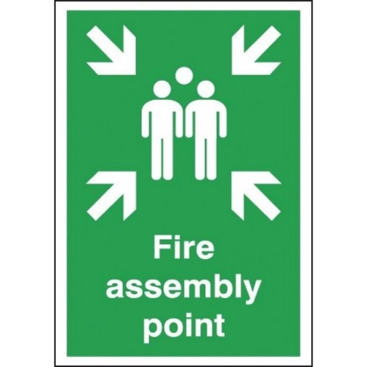
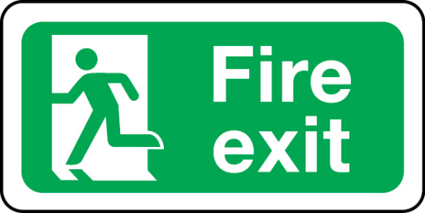

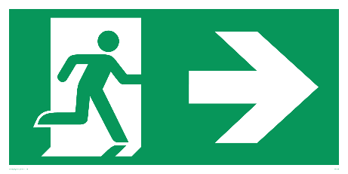

- DO Follow the instructions of the Fire Evacuation Marshals who will be wearing bright yellow jackets.
- DO NOT run
- DO NOT use the lifts
- DO NOT stop to gather your belongings.
- DO NOT congregate outside the Engineering Building as this will block access for the emergency services.
- DO NOT re-enter the building unless told to do so by a Fire Evacuation Marshal.

Please also be aware of the following Covid-19 guidance:

- Wherever possible, observe 2 metre social distancing whilst evacuating. This is particularly important on stairs, at final exits and moving to the fire assembly point.
- Fire evacuation routes and assembly points remain unchanged for the Roberts building. Use every fire escape route to reduce congestion and any bunching on stairs and exits.
- If there is a conflict between social distancing and rapid evacuation, focus on getting out quickly as the priority.
- Once outside the building, move to assemble by the building Fire Assembly Points, observing social distancing as far as possible.
- When given the 'all clear' to return to a building, make sure to re-enter by staggering the return.
- When re-entering a building, wash or sanitise your hands.

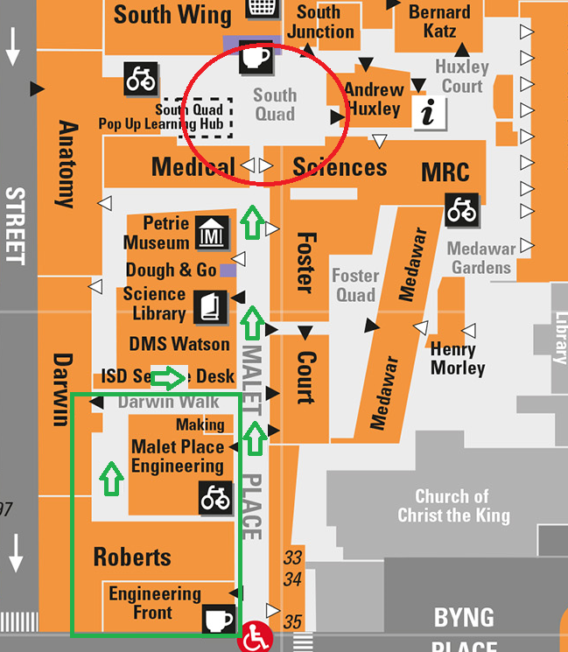
For the Roberts building & MPEB the assembly point is the Anatomy Yard; walk through the arch in the Medical Sciences Building to the quadrangle near the South Junction (next to where the print room café tables are situated).

Roberts fire escape routes
The Roberts building has two stairs, one on the West and one on the East side of the building. All floors from the 6th through to the 10th have the same corridor arrangement (see 6th floor plan below). If the fire alarm sounds, please evacuate using the nearest stair.
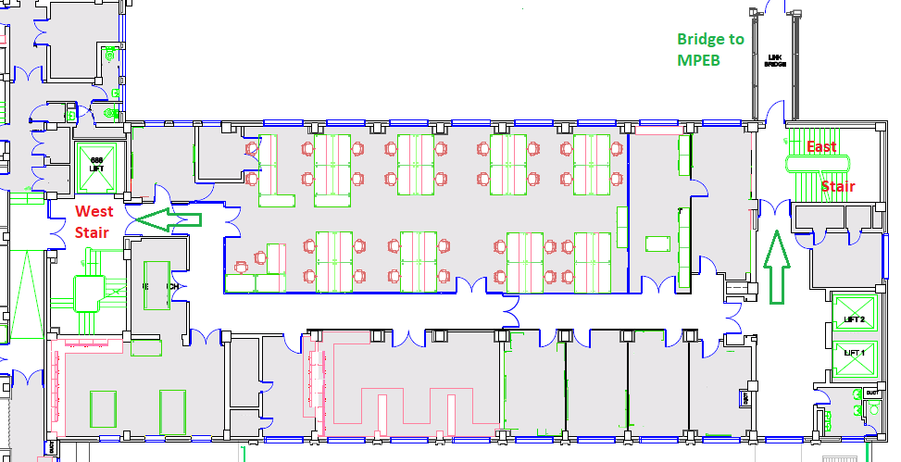
The 11th floor has a slightly different layout but also has East and West stair access points. Please be careful evacuating this floor as the stairs between the 11th and 10th floors are very narrow.
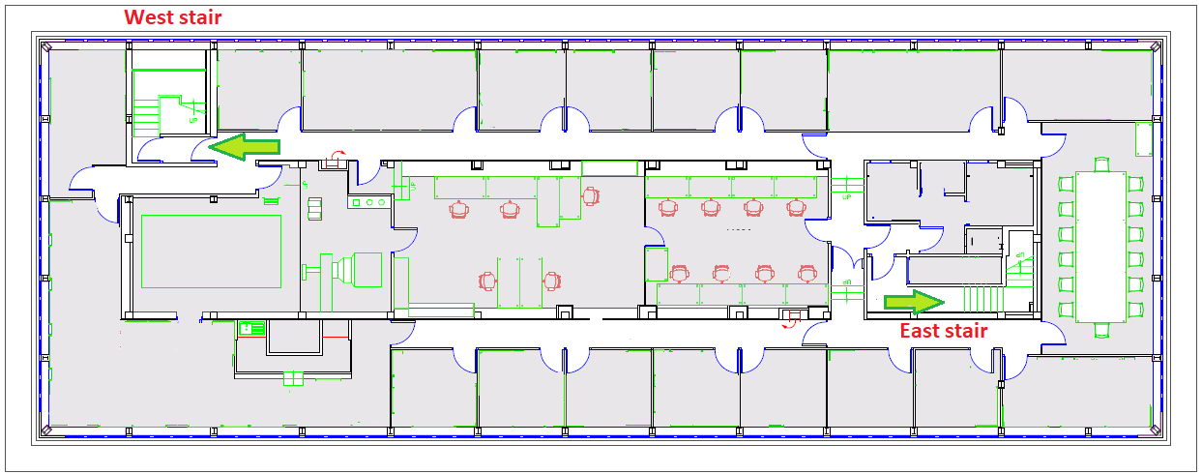
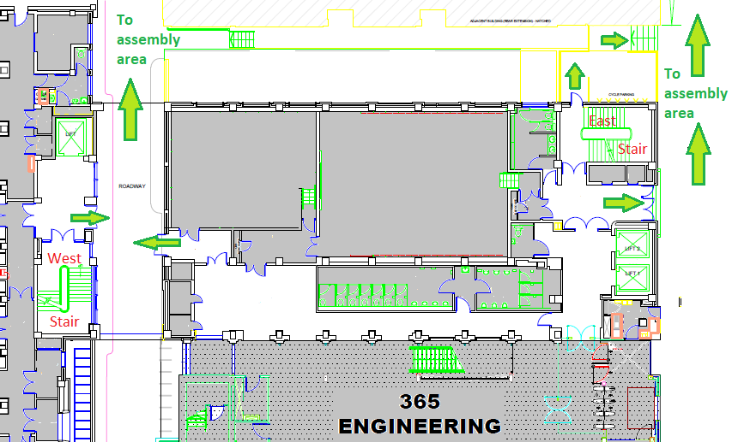
Once you have reached the ground floor, the main fire exit point is next to the Roberts lift lobby. You can also exit the building via doors on the North and West (rear) sides of the building. At the West or Rear side of Roberts, there is an archway and road which runs under the building. The ground floor lobby of the West stair exits on to this road. To get to the assembly point from the rear of the Roberts building, proceed North behind the MPEB and turn right to re-join Malet Place.

There are bridges linking the Roberts abuilding and MPEB on the 1st through 7th floors, connecting directly to the East stairwell of Roberts building.

MPEB escape routes
The MPEB has stairs at the front and rear of the building- please see plan of the 7th floor below. Both of these have exits on the ground floor.
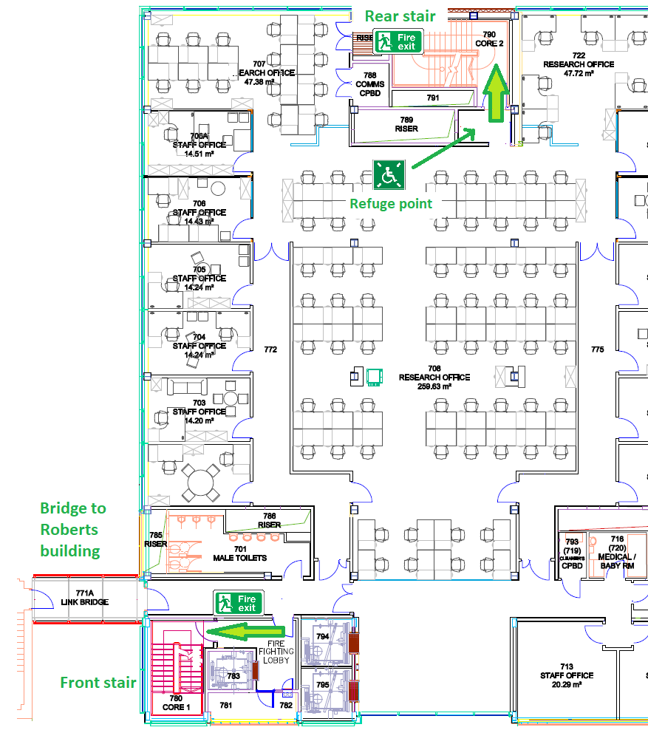

Personal Emergency Evacuation Plans
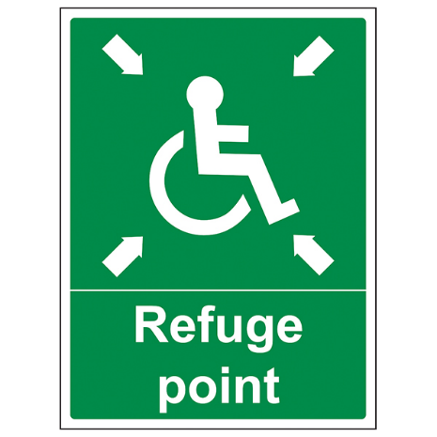
People who have a personal emergency evacuation plan (PEEP) will require assistance in getting to the designated refuge point. The Roberts refuge points are located on each East stairwell and the West floor emergency exit. MPEB refuge points are on every floor within each stairwell. Refuge points are indicated by the If you think you will require assistance during a fire evacuation, please notify your line manager or supervisor who will show you the nearest refuge point to your work location. Guidance on PEEPs may be found here on the University Fire Safety website.

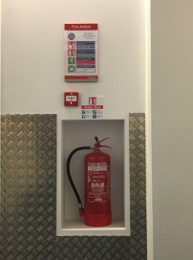
If you discover fire or smoke operate the nearest fire alarm break glass point. These are situated at the end of each corridor. Dial 222 on any internal telephone in UCL (or 020 7679 2222 on mobile) and give Security the building name and Fire Zone number:

045 for the Roberts Building

365 for the Engineering Front Building

350 for the MPEB

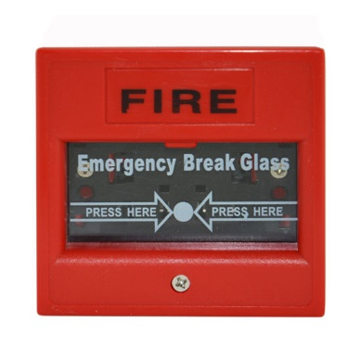
This information is also displayed at each break glass point and in the stairwells on each floor.

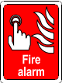
Our buildings are fitted with an automatic fire detection system. The system is a series of smoke detectors which are situated in the corridors and a few selected laboratories are also connected centrally.

This should automatically call the Fire Service in the event of a fire. It is important however that in the event of a fire to raise the alarm independently of the fire detection system, as described above.

Fire exits & fire doors

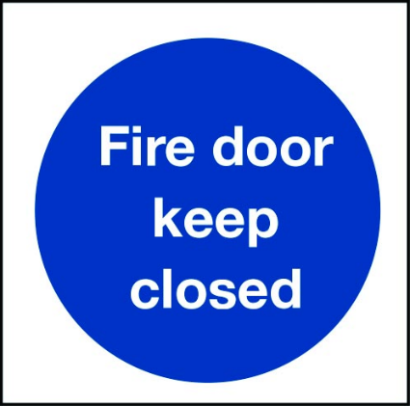
Fire doors are usually marked with a blue circular sign with one of the following messages: ‘Fire Door/ ‘Fire Keep Shut’ / ‘Fire Door Keep Locked’. It is vitally important that these are never blocked or wedged open- fire doors not only hold back heat and flames for a period but also prevent the spread of dangerous smoke. If you are moving equipment or materials and need doors to be held open, request assistance for colleagues or technical staff.

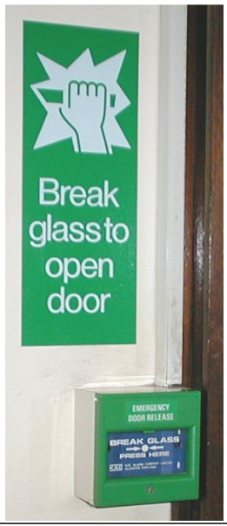
Our corridor doors have electronic ‘hold open’ systems, which are usually in operation during normal hours (7am to 7pm). These are connected to the building fire alarm system and will automatically close the doors if the alarms sound. As of October 2020, these have been temporarily disabled as a security measure.

Any doors that have an electronic lock- for example, doors opened via card access from the exterior- will have a push button release on the interior. In general, they will unlock automatically if the fire alarm is activated. Should this fail, there will always be a break glass or lever override door release available to use. All doors with electronic mechanisms will unlock (or ‘fail open’) in the event of power loss. Be careful to not confuse the emergency release with the normal door release button- as these are both usually green- or to confuse the emergency release with the fire break glass points (the fire ones are red!).

One-way fire doors are also commonly fitted with mechanical opening devices:
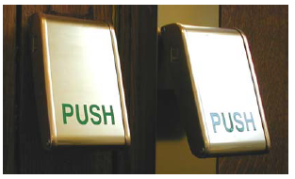
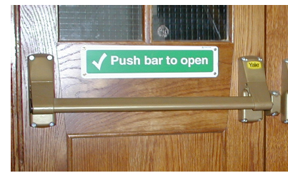
- Push bar and push panel door releases require you to push down on the bar or panels to open the door.

- Simple thumb-turn types are operated as indicated on the accompanying sign, which will show the correct direction to turn.
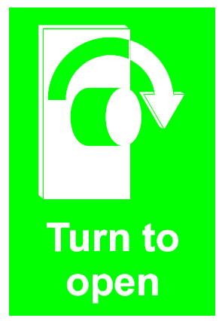
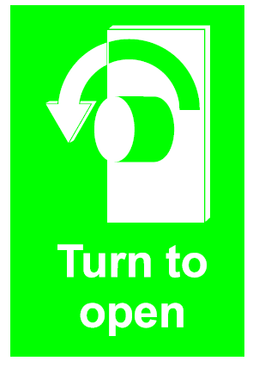
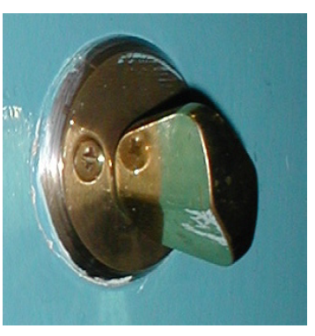

- Other types have a plastic dome or covering to make sure the door release is not used accidentally. These are normally a thumb turn or lever.

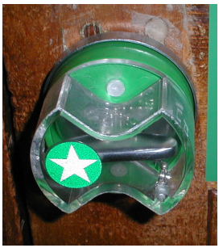
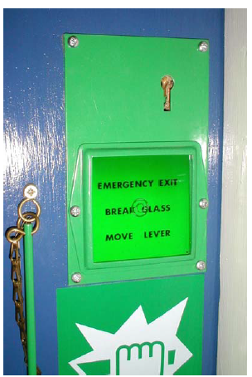

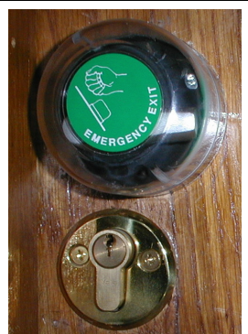

You must break open the covering to get to the release mechanism. Some systems will have a break glass hammer provided to make this easier. If a release mechanism of one of these types has been used, the covering needs to be replaced professionally- report this to defects@ee.ucl.ac.uk.

Make sure you are aware of any of these systems in your work area. They should be pointed out to you during the fire safety walk.

Firefighting & fire controls

There is no expectation for UCL staff to fight fires directly, and unless you have received specific training you should not use fire extinguishers.

Department buildings are provided with hand-held extinguishers at key points in corridors. These are of either CO₂ or water-mist types. These are suitable for both paper and electrical fires.
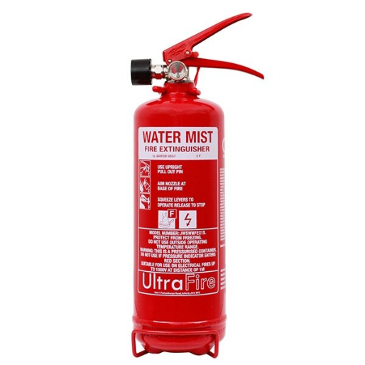
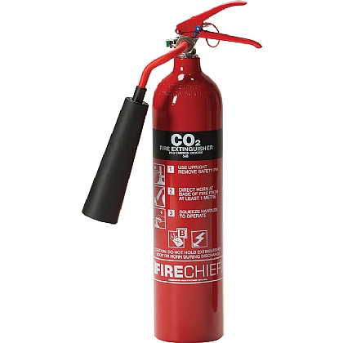

Other types of hand-held firefighting gear may be present in certain laboratories and workshops depending on the hazards- you will be informed of these if you will work in these areas.

In the Roberts building you will also see other fire control measures such as fire shutters and fire hoses at the entry to each floor. The fire hoses are for the use of the emergency services only. The fire shutters are historic and are no longer required by the building fire safety plan- please do not be concerned by the ‘out of use’ notices on these!

Fire drills

Periodically the College carries out fire drills. The object is to ensure people aware of the fire evacuation procedures and to practice fast evacuation of the building. Not all drills will be notified in advance.

Please respond to drills as in a real emergency. Do not assume any evacuation is just a drill.

Specific instructions for labs and workshops
If you will be working in an area with specific shut down or exit requirements in the event of an evacuation- in a lab or workshop, for example- instruction on these procedures will be given in your local induction for the area provided by the workshop or lab manager, or your supervisor.

Fire Safety symbols and instruction signs
You will see a variety of different fire and safety instruction messages around our buildings including variations on the examples above. Rather than provide an exhaustive list of fire safety signs you will see around campus it is more important that you understand what the different colours and categories of symbols mean and follow all instructions on safety signage. These are likely to be very familiar as the colours and symbols are standardised worldwide, but you may notice some differences in style if are joining UCL from overseas.
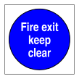
Mandatory – Blue circle
Any signs with a blue colour display mandatory rules- you must follow the instructions on these signs.
Safe condition - Green square/rectangle
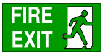
These signs indicate a either a safe location, a route to a safe location, or the location of safety equipment (e.g., first aid or emergency phone).

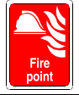
Fire equipment - Red square or rectangle
Indicates the presence of fire-fighting equipment and also fire alarm break glass points.

Warning/Hazard- Yellow triangle
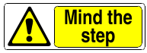
Indicates the presence of a hazard, e.g., dangerous area, dead end, or trip hazard, that may encounter either in our work area or on your escape route.

Contingency Plans

Low Oxygen & Cryogen Emergencies

Asphyxiation – If you know or suspect a colleague is suffering from asphyxiation due to a low oxygen emergency then call Security on the emergency hotline (222) from any internal phone and ask them to call for the emergency services.

UNDER NO CIRCUMSTANCES SHOULD YOU ENTER A SUSPECTED LOW OXYGEN ENVIRONMENT.
DO NOT ATTEMPT A RESCUE – YOU WILL BECOME A CASUALTY!

Oxygen depletion alarms
If a laboratory oxygen depletion alarm sounds while you are working inside, all persons should evacuate the area immediately;
- Prevent others from entering the laboratory.
- Do not re-enter until:
  - the alarm has stopped sounding
  - the displayed oxygen level has returned to normal
- Report the incident to the laboratory manager, Department Safety Officer and the Technical Services Manager. Normal work should not resume until the cause of the alarm has been investigated.
If you are in the vicinity and discover that a laboratory oxygen depletion alarm is sounding:
- Notify the laboratory manager, Department Safety Officer and the Technical Services Manager. If they are not available, inform Security on 222.
- Prevent others from entering the area.

Spills and/or Vessel failure – In the event of a large spill of cryogenic liquid, or the failure of a pressure vessel storing cryogenic gas, all persons should evacuate the room immediately.
- Prevent others from entering the laboratory.
- Report the incident to the laboratory manager, Department Safety Officer and the Technical Services Manager. Work with cryogens should not resume until the cause of the spillage has been investigated.
Direct Exposure to cryogenic liquid/gas – Small exposure can be treated as burns with tepid water:
- Run the affected area under tepid water for 15 minutes.
- Contact a department first aider or Security (222) if they are not available.
- Seek medical assistance for large exposures which cover an area of skin greater than a 50p coin.

Laser injuries

For immediate ocular injury accidents where there is an apparent eye injury:
- The casualty should be sat in an upright position, rather than laying down, to avoid debris settling on the retina.
- If the injuries are severe enough to induce shock in the casualty, then normal First Aid procedures for the treatment of shock override this consideration.

Any equipment and laser systems involved must be isolated pending a full investigation by the Laser Safety Officer and Department Safety Officer.

DO NOT CONTINUE WORKING with the system that caused the accident.

If there is an apparent or suspected injury to the eye, the injured person should see a specialist ophthalmologist at the as soon as possible, and definitely within 24 hours.
- The injured person should not drive and should be accompanied by a colleague. They should be transported in an ambulance if necessary.
- If an ophthalmologist is not available at the University College Hospital A&E, the injured person should be sent within 24 hours to Moorfields Eye Hospital where the medics are experienced in dealing with laser eye injuries.

Details of the laser beam should accompany the casualty to hospital. These should include type of laser system, classification, wavelength, power/energy per pulse and pulse duration. You should keep a copy of this information readily available in the laboratory in case of emergency.

An accident report must be filed with Safety Services. The Laser Safety Officer must also report any injury to UCL Health & Wellbeing to ensure follow up for the injured person.

University College Hospital Accident and Emergency Department Address: Grafton Way, London, NW1 2BU

(within a short walking distance of the UCL Bloomsbury Campus)

Moorfields Eye Hospital Accident and Emergency Department (open 24 hours a day). Address: 162 City Road, London, EC1V 2PD

Nearest Underground Station: Old Street, Northern Line.

Electrical shock
Where a serious electrical shock is suspected, act to break the contact between the casualty and the electrical supply.
- If it is possible to do so safely, you should turn off the source of electricity, by switching off the current at the mains, turning the power off at the circuit board etc.
- Alternatively, move the source of the shock away using an object of low conductivity. Stand on a dry insulating material, such as a book, newspapers or rubber matting and use a long, low-conductivity object to push the power source away from the casualty, or to free the casualty's limbs from contact with the source.
Immediately request assistance from Security (222) to call for the emergency services and the support of a first aider.

